# Analysis Overview

The purpose of this project is to create an algorithm to predict whether or not applicants for funding will be successful. We will build, train, test, and optimize a deep neural network to determine if the loan success based on nine features in a loan application data set.

We implemented TensorFlow Keras Sequential model with Dense hidden layers and an Output Layer Activation Function

# Resources

* Data Source:
  + charity_data.csv
* Software:
  + Python 3.9.7
  + Scikit-learn 1.0.2
  + Pandas 1.3.4
  + TensorFlow 2.8.0
  + Matplotlib 3.4.3

# Data Pre-processing

We first preprocess our data set *charity_data.csv* by reading our data and identifying the following target, feature, and identification variables:

* Target Variable: IS_SUCCESSFUL
* Feature Variables: APPLICATION_TYPE, AFFILIATION, CLASSIFICATION, USE_CASE, ORGANIZATION, STATUS, INCOME_AMT, SPECIAL_CONSIDERATIONS, ASK_AMT
* Identification Variables (to be removed): EIN, NAME

After processing our data, we use the OneHotEncoder Module to convert categorical variables into numeric variables. Once the data was binary encoded, we split it into the target and features and then into training and testing sets. We also had to scale our training and testing data using the StandardScaler Module.

# Attempt 1

|  |  |
| --- | --- |
| **Parameter** | **Value** |
| Number of Hidden Layers | **2** |
| Architecture (hidden_nodes1, hidden_nodes2) | **(50, 30)** |
| Hidden Layer Activation Function | **relu** |
| Number of Output Nodes | **1** |
| Output Layer Activation Function | **sigmoid** |



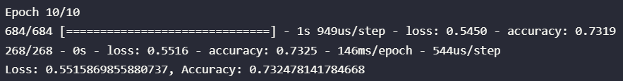

# Attempt 2

|  |  |
| --- | --- |
| **Parameter** | **Value** |
| Number of Hidden Layers | **2** |
| Architecture (hidden_nodes1, hidden_nodes2) | **(80, 40)** |
| Hidden Layer Activation Function | **relu** |
| Number of Output Nodes | **1** |
| Output Layer Activation Function | **sigmoid** |



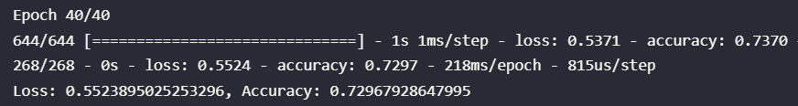

# Attempt 3

|  |  |
| --- | --- |
| **Parameter** | **Value** |
| Number of Hidden Layers | **3** |
| Architecture (hidden_nodes1, hidden_nodes2, hidden_nodes3) | **(100, 100, 50)** |
| Hidden Layer Activation Function | tanh |
| Number of Output Nodes | **1** |
| Output Layer Activation Function | **sigmoid** |



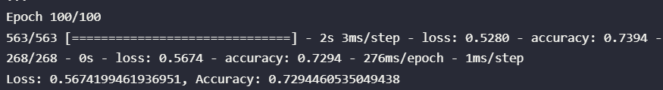

# Summary

In summary, our deep neural network classification model that predicts loan applicant success based on charity_data.csv with 73% accuracy. This does not meet the 75% accuracy target, the multiple optimization methods implemented did not show significant improvement.